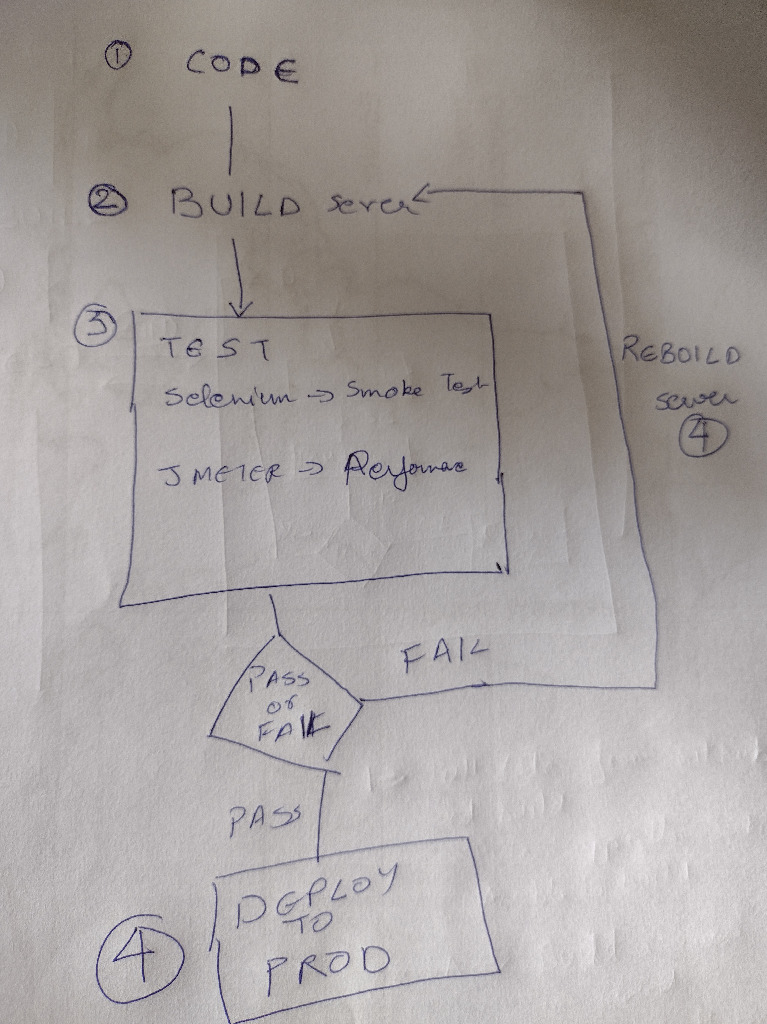

|  |  |  |
| --- | --- | --- |
|  | **Steps** | **Comments** |
| 1 | a) Pull Source Code from a repository  b) Build the code. | Shall i take a sample source code favailable for free – something simple in node js?   If it is node.js, then do i need to build it? What i mean is – myy undestanding is that “To Build” means like importing all required packages and then compiling the code to make a class file, alley? In case of node.js is there anythign like it? |
| 2 | a) Build a Test Env app server to deploy the code based on input config files, and then build another server where the test tool will be deployed  b) Deploy the build in the Test env app server, and install Selenium and Apach Jmeter in the other server | Build a server in Azure? The server will be built by picking specifications in a config file |
| 3 | Run the Automated Selenium Test – This will be smoke test  Run the Apache Jmeter Test – This will be the performance Test |  |
| 4 | If the perf test is a pass, then convert the test app server into PROD  If the perf test test is a fail, then check the memory and the CPU on the app server. Restart the steps from 2b, Rebuild the server with higher CPU or memory based on perf test results |  |